
Click or tap here to enter text.
Click or tap here to enter text.

Building ID: Click or tap here to enter text.
Insert Report Date

Click or tap here to enter text.

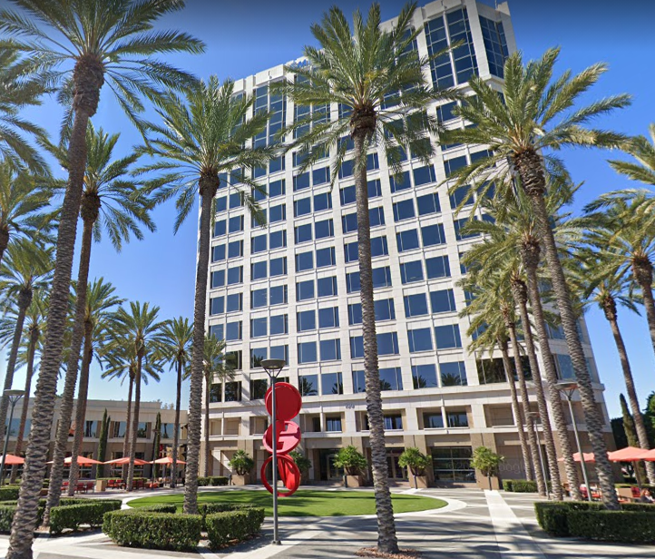

ASHRAE Level II Energy Audit, Water Audit
& Retro-commissioning Report
Prepared by:
Vert Energy Group, Inc.
100 Spectrum Center Drive, Suite 900
Irvine, California, 92618

Phone: (800) 585-2690
Email: info@vertenergygroup.com

Table of Contents
I. Executive Summary 4
A. Introduction: 4
B. Summary Tables 5
C. EEMs, WEMs & RCMs Performance Analysis Summary 6
D. EEM, WEM & RCM Financial Analysis Summary 7
E. Next Steps 8
II. ASHRAE Level II Energy Audit Report 9
A. Introduction 9
B. Energy Audit Procedures 9
C. EEMs Cost Savings Summary Table 10
D. Existing Conditions and Observations 11
E. Energy Efficiency Measures Recommended 12
F. EEMs Already Implemented 17
G. EEMs to Consider 18
H. EEMs Requiring Further Investigation 19
I. Current ENERGY STAR® Benchmarking Test 20
J. Energy Use Analysis 21
III. Water Audit Report 28
A. Introduction 28
B. Water Audit Procedures 28
C. WEMs Cost Savings Summary Table 30
D. Existing Conditions and Observations 31
E. Water Efficiency Measures Recommended 32
F. WEMs Already Implemented 38
G. WEMs to Consider 39
H. WEMs Requiring Further Investigation 40
I. Non-Efficiency Water Measure/s 41
J. Water Use Analysis 42
IV. Retrocommissioning Report 46
A. Introduction 46
B. Objectives 46
C. Overview of Results 46
D. RCMs Cost Savings Summary Table 47
E. Overview of Project Steps 48
F. Retrocommissioning Plan 48
G. Functional Performance Test Methodology 49
H. Assessment Team 50
I. Functional Performance Test Findings & Recommendations 51
J. Operational Training 53
V. Appendices 54
A. Assumptions 55
B. Equations: 56
C. Supporting Documents 57
D. Equivalent Full Load Hours (EFLH) 59
E. Additional O& M 60
B. LADWP Rebates 61

Executive Summary

Introduction:
At the request of Click or tap here to enter text., Vert Energy Group (VEG) performed ASHRAE Level II Energy Audit, Water Audit and a retro-commissioning (RCx) study of the base building systems at Click or tap here to enter text. [Enter short description of the building from the EC&O section]
The study is referred to as The Existing Buildings Energy and Water Efficiency (EBEWE) Program, was established by Los Angeles Municipal Code (LAMC) Division 97, Article 1, Chapter IX with the purpose of reducing energy and water consumption by building in the City of Los Angeles. The efficiency improvements (if implemented) will lower the use of energy, water, and greenhouse gas emissions citywide.
The Energy Efficiency Audit Scope of Work includes:
- Perform an on-site facility survey of existing mechanical, electrical, lighting, and control systems, and interview the critical operations and maintenance personnel.
- Summarize observations, existing conditions, necessities, and opportunities.
- Analyze energy use and ENERGY STAR® benchmarking.
- Identify and summarize Energy Efficiency Measures (EEMs) based on a 10-year ownership strategy.
- Prepare an Energy Management Plan to achieve the following objectives.
- Reduce energy usage and cost through equipment and control upgrades
- Improve energy performance.
- Reduce water usage and cost through equipment and control upgrades
- Reduce water usage and cost thru operation and maintenance
The Water Audit Scope of Work includes:
- Perform an on-site facility survey of existing water-using fixtures, equipment, systems, and processes, and interview the critical operations and maintenance personnel.
- Summarize observations, existing conditions, necessities, and opportunities.
- Analyze water use and water use intensity (WUI).
- Identify and summarize Water Efficiency Measures (WEMs) based on a 10-year ownership strategy.
- Prepare a Management Plan to achieve the following objectives.
- Reduce water usage and cost through equipment and control upgrades.
- Reduce water usage and cost through monitoring & repairs
- Reduce water usage and cost thru operation and maintenance
The Retro-commissioning (RCx) study Scope of Work included:
- Perform an on-site facility survey of existing mechanical, electrical, lighting, and control systems, and interview the critical operations and maintenance personnel.
- Summarize observations, necessities, and opportunities.
- Identify and summarize Retro-commissioning Measures (RCMs) to be implemented.
- Prepare a Retro-commissioning Plan to achieve the following objectives.
- Correct existing equipment and system problems and deficiencies
- optimize the building systems via tune-up activities
- Improve operation and maintenance (O&M)
- Reduce maintenance costs and improve long-term equipment reliability

Summary Tables
[Number] (number) energy and water efficiency measures were analyzed and recommended. These measures have estimated annual savings of #DIV/0! with #DIV/0! years payback if incentives are still applicable and awarded.
REPORT SUMMARY
Building Square Footage (sq.ft.)
Annual Energy Cost | $0
Current ENERGY STAR® Rating
Current Energy Use Intensity (EUI) | #DIV/0!
Current Energy Cost / sq.ft. | #DIV/0!
Annual Water/Sewer Cost | $0
Current Energy STAR® Water Score Rating
Current Water Use Intensity (WUI)
Current water/Sewer Cost / sq.ft. | #DIV/0!
Target Annual Savings from Energy Upgrades | #DIV/0!
Target Annual Savings from Water Upgrades | #DIV/0!
Target Annual Savings from RCx Implementation | #DIV/0!
Combined Potential Annual Savings (Energy & Water) | #DIV/0!
Combined Potential Cost Saving (After Rebates) | $0

EEMs, WEMs & RCMs Performance Analysis Summary
The following table summarizes the overall performance of energy and water efficiency measures recommended as part of the Energy Management Plan.

EEMs, WEMs & RCMs SUMMARY TABLE
Measure # | Descriptions | Cost Savings | KWH Savings | KW Savings | Therms Savings | Lbs Steam Savings | Gallons Savings | Estimated Project Cost | Incentives | Net Cost | Useful Life (Years)
EEM 1 | 0 | #DIV/0! | 0 | 0 | 0 | 0 | 0 | 0 | 0 | 0 | 0
EEM 2 | 0 | #DIV/0! | 0 | 0 | 0 | 0 | 0 | 0 | 0 | 0 | 0
EEM 3 | 0 | #DIV/0! | 0 | 0 | 0 | 0 | 0 | 0 | 0 | 0 | 0
EEM 4 | 0 | #DIV/0! | 0 | 0 | 0 | 0 | 0 | 0 | 0 | 0 | 0
EEM 5 | 0 | #DIV/0! | 0 | 0 | 0 | 0 | 0 | 0 | 0 | 0 | 0
EEM 6 | 0 | #DIV/0! | 0 | 0 | 0 | 0 | 0 | 0 | 0 | 0 | 0
EEM 7 | 0 | #DIV/0! | 0 | 0 | 0 | 0 | 0 | 0 | 0 | 0 | 0
EEM 8 | 0 | #DIV/0! | 0 | 0 | 0 | 0 | 0 | 0 | 0 | 0 | 0
EEM 9 | 0 | #DIV/0! | 0 | 0 | 0 | 0 | 0 | 0 | 0 | 0 | 0
EEM 10 | 0 | #DIV/0! | 0 | 0 | 0 | 0 | 0 | 0 | 0 | 0 | 0
EEM 11 | 0 | #DIV/0! | 0 | 0 | 0 | 0 | 0 | 0 | 0 | 0 | 0
EEM 12 | 0 | #DIV/0! | 0 | 0 | 0 | 0 | 0 | 0 | 0 | 0 | 0
EEM 13 | 0 | #DIV/0! | 0 | 0 | 0 | 0 | 0 | 0 | 0 | 0 | 0
EEM 14 | 0 | #DIV/0! | 0 | 0 | 0 | 0 | 0 | 0 | 0 | 0 | 0
WEM 1 | 0 | #DIV/0! | 0 | 0 | 0 | 0 | 0 | 0 | 0 | 0 | 0
WEM 2 | 0 | #DIV/0! | 0 | 0 | 0 | 0 | 0 | 0 | 0 | 0 | 0
WEM 3 | 0 | #DIV/0! | 0 | 0 | 0 | 0 | 0 | 0 | 0 | 0 | 0
WEM 4 | 0 | #DIV/0! | 0 | 0 | 0 | 0 | 0 | 0 | 0 | 0 | 0
WEM 5 | 0 | #DIV/0! | 0 | 0 | 0 | 0 | 0 | 0 | 0 | 0 | 0
WEM 6 | 0 | #DIV/0! | 0 | 0 | 0 | 0 | 0 | 0 | 0 | 0 | 0
WEM 7 | 0 | #DIV/0! | 0 | 0 | 0 | 0 | 0 | 0 | 0 | 0 | 0
WEM 8 | 0 | #DIV/0! | 0 | 0 | 0 | 0 | 0 | 0 | 0 | 0 | 0
WEM 9 | 0 | #DIV/0! | 0 | 0 | 0 | 0 | 0 | 0 | 0 | 0 | 0
WEM 10 | 0 | #DIV/0! | 0 | 0 | 0 | 0 | 0 | 0 | 0 | 0 | 0
RCM 1 | 0 | #DIV/0! | $0 | $0 | $0 | $0 | $0 | $0 | $0 | $0 | $0
RCM 2 | 0 | #DIV/0! | $0 | $0 | $0 | $0 | $0 | $0 | $0 | $0 | $0
RCM 3 | 0 | #DIV/0! | $0 | $0 | $0 | $0 | $0 | $0 | $0 | $0 | $0
RCM 4 | 0 | #DIV/0! | $0 | $0 | $0 | $0 | $0 | $0 | $0 | $0 | $0
RCM 5 | 0 | #DIV/0! | $0 | $0 | $0 | $0 | $0 | $0 | $0 | $0 | $0
RCM 6 | 0 | #DIV/0! | $0 | $0 | $0 | $0 | $0 | $0 | $0 | $0 | $0
RCM 7 | 0 | #DIV/0! | $0 | $0 | $0 | $0 | $0 | $0 | $0 | $0 | $0
RCM 8 | 0 | #DIV/0! | $0 | $0 | $0 | $0 | $0 | $0 | $0 | $0 | $0
RCM 9 | 0 | #DIV/0! | $0 | $0 | $0 | $0 | $0 | $0 | $0 | $0 | $0
RCM 10 | 0 | #DIV/0! | $0 | $0 | $0 | $0 | $0 | $0 | $0 | $0 | $0
TOTAL |  | #DIV/0! | 0 | 0 | 0 | 0 | 0 | 0 | 0 | 0

*Note:
- Since the equipment in EEM- has reached the end if it’s useful life, the financial analysis was based on incremental cost and not the total cost of replacement.
- The incremental cost of implementing an energy saving measure is the incremental cost of the more‐efficient measure compared to the cost of a code‐compliant or current practice measure.

EEM, WEM & RCM Financial Analysis Summary
The following table summarizes the analysis of key financial metrics for each energy, water & retro-commissioning measure.

EEMs, WEMs & RCMs FINANCIAL ANALYSIS
Measure # | Descriptions | Simple Payback (yrs) | NPV | ROI | IRR | MIRR | Annual Increase in NOI | Annual Savings / sq.f.t | Cost / sq.f.t | Increase in Asset Value
EEM 1 | 0 | 0.0 | #DIV/0! | 0% | 0% | 0% | #DIV/0! | #DIV/0! | #DIV/0! | #DIV/0!
EEM 2 | 0 | 0.0 | #DIV/0! | 0% | 0% | 0% | #DIV/0! | #DIV/0! | #DIV/0! | #DIV/0!
EEM 3 | 0 | 0.0 | #DIV/0! | 0% | 0% | 0% | #DIV/0! | #DIV/0! | #DIV/0! | #DIV/0!
EEM 4 | 0 | 0.0 | #DIV/0! | 0% | 0% | 0% | #DIV/0! | #DIV/0! | #DIV/0! | #DIV/0!
EEM 5 | 0 | 0.0 | #DIV/0! | 0% | 0% | 0% | #DIV/0! | #DIV/0! | #DIV/0! | #DIV/0!
EEM 6 | 0 | 0.0 | #DIV/0! | 0% | 0% | 0% | #DIV/0! | #DIV/0! | #DIV/0! | #DIV/0!
EEM 7 | 0 | 0.0 | #DIV/0! | 0% | 0% | 0% | #DIV/0! | #DIV/0! | #DIV/0! | #DIV/0!
EEM 8 | 0 | 0.0 | #DIV/0! | 0% | 0% | 0% | #DIV/0! | #DIV/0! | #DIV/0! | #DIV/0!
EEM 9 | 0 | 0.0 | #DIV/0! | 0% | 0% | 0% | #DIV/0! | #DIV/0! | #DIV/0! | #DIV/0!
EEM 10 | 0 | 0.0 | #DIV/0! | 0% | 0% | 0% | #DIV/0! | #DIV/0! | #DIV/0! | #DIV/0!
EEM 11 | 0 | 0.0 | #DIV/0! | 0% | 0% | 0% | #DIV/0! | #DIV/0! | #DIV/0! | #DIV/0!
EEM 12 | 0 | 0.0 | #DIV/0! | 0% | 0% | 0% | #DIV/0! | #DIV/0! | #DIV/0! | #DIV/0!
EEM 13 | 0 | 0.0 | #DIV/0! | 0% | 0% | 0% | #DIV/0! | #DIV/0! | #DIV/0! | #DIV/0!
EEM 14 | 0 | 0.0 | #DIV/0! | 0% | 0% | 0% | #DIV/0! | #DIV/0! | #DIV/0! | #DIV/0!
WEM 1 | 0 | 0.0 | #DIV/0! | 0% | 0% | 0% | #DIV/0! | #DIV/0! | #DIV/0! | #DIV/0!
WEM 2 | 0 | 0.0 | #DIV/0! | 0% | 0% | 0% | #DIV/0! | #DIV/0! | #DIV/0! | #DIV/0!
WEM 3 | 0 | 0.0 | #DIV/0! | 0% | 0% | 0% | #DIV/0! | #DIV/0! | #DIV/0! | #DIV/0!
WEM 4 | 0 | 0.0 | #DIV/0! | 0% | 0% | 0% | #DIV/0! | #DIV/0! | #DIV/0! | #DIV/0!
WEM 5 | 0 | 0.0 | #DIV/0! | 0% | 0% | 0% | #DIV/0! | #DIV/0! | #DIV/0! | #DIV/0!
WEM 6 | 0 | 0.0 | #DIV/0! | 0% | 0% | 0% | #DIV/0! | #DIV/0! | #DIV/0! | #DIV/0!
WEM 7 | 0 | 0.0 | #DIV/0! | 0% | 0% | 0% | #DIV/0! | #DIV/0! | #DIV/0! | #DIV/0!
WEM 8 | 0 | 0.0 | #DIV/0! | 0% | 0% | 0% | #DIV/0! | #DIV/0! | #DIV/0! | #DIV/0!
WEM 9 | 0 | 0.0 | #DIV/0! | 0% | 0% | 0% | #DIV/0! | #DIV/0! | #DIV/0! | #DIV/0!
WEM 10 | 0 | 0.0 | #DIV/0! | 0% | 0% | 0% | #DIV/0! | #DIV/0! | #DIV/0! | #DIV/0!
RCM 1 | 0 | 0.0 | #DIV/0! | 0% | 0% | 0% | #DIV/0! | #DIV/0! | #DIV/0! | #DIV/0!
RCM 2 | 0 | 0.0 | #DIV/0! | 0% | 0% | 0% | #DIV/0! | #DIV/0! | #DIV/0! | #DIV/0!
RCM 3 | 0 | 0.0 | #DIV/0! | 0% | 0% | 0% | #DIV/0! | #DIV/0! | #DIV/0! | #DIV/0!
RCM 4 | 0 | 0.0 | #DIV/0! | 0% | 0% | 0% | #DIV/0! | #DIV/0! | #DIV/0! | #DIV/0!
RCM 5 | 0 | 0.0 | #DIV/0! | 0% | 0% | 0% | #DIV/0! | #DIV/0! | #DIV/0! | #DIV/0!
RCM 6 | 0 | 0.0 | #DIV/0! | 0% | 0% | 0% | #DIV/0! | #DIV/0! | #DIV/0! | #DIV/0!
RCM 7 | 0 | 0.0 | #DIV/0! | 0% | 0% | 0% | #DIV/0! | #DIV/0! | #DIV/0! | #DIV/0!
RCM 8 | 0 | 0.0 | #DIV/0! | 0% | 0% | 0% | #DIV/0! | #DIV/0! | #DIV/0! | #DIV/0!
RCM 9 | 0 | 0.0 | #DIV/0! | 0% | 0% | 0% | #DIV/0! | #DIV/0! | #DIV/0! | #DIV/0!
RCM 10 | 0 | 0.0 | #DIV/0! | 0% | 0% | 0% | #DIV/0! | #DIV/0! | #DIV/0! | #DIV/0!
TOTAL |  | #DIV/0! | #DIV/0! | #DIV/0! | #VALUE! | #DIV/0! | #DIV/0! | #DIV/0! | #DIV/0! | #DIV/0!

Next Steps

The Energy Efficiency Measures summarized above and throughout the report are conceptual. Additional technical due-diligence, planning and design are required prior to implementation. Specifically, management and Vert Energy Group should first set up a planning meeting to determine which measures should be considered for further development and if they contribute to the overall goals of ownership.

The following additional tasks are recommended to implement the proposed Energy Management Plan.
- Engineering due-diligence, analysis, and preliminary design to confirm overall project performance.
- LADWP research and negotiation to determine final rebate amounts.
- Project engineering and permitting as applicable.
- Contractor solicitation and budgeting.
- Financing and execution of construction contracts.
To commence the proposed Energy Management Program (EMP) Property Management should first consider proceeding with energy efficiency measures which have the highest Net Present Values (NPV), and the lowest pay back periods. Additionally, VEG has provided the following guidelines to assist in prioritizing energy efficiency measures.

EEMs & RCM recommended to be implemented first may result in one or more of the following benefits.
- Independent of all other EEM’s.
- The simplest to implement.
- The most cost effective.
- Visible to occupants and guests.


ASHRAE Level II Energy Audit Report

Introduction
An ASHARE level II energy audit was performed at Click or tap here to enter text. on Click or tap here to enter text. & Click or tap here to enter text. in accordance with ASHRAE procedures & guidelines for building energy audits.
The audit identifies no-cost, low-cost and potential capital-intensive energy savings opportunities. In addition, the report provides a list of EEM recommendations along with an analysis of the energy costs, energy usage and building characteristics.

Energy Audit Procedures
The Energy audit procedure consists of the following tasks:
Conduct a Pre-Audit Call
- Discuss the upcoming audit with the site staff.
- Discuss the site visit procedures.
- Discuss the use of photography during the site visit.
- Request document needed for the energy audit.
Documents Review
- Metering/utility bills analysis.
- Review Portfolio Manager.
- Review as-built plans.
- Review previous energy assessments.
- Review a comprehensive maintenance report of fixtures kept by on-site staff to determine any potential maintenance needs.
Site Visit
- Collect information related to building’s energy use, occupancy, operation, and occupant behavior.
- Review important energy-using systems, processes, and equipment.
- Gathering existing equipment name plate information.
- Gathering existing equipment controls strategies.
- Conduct Performance tests/Collect quantitative data such as:
    - surface temperatures with an infrared thermometer.
    - IAQ: Space temperatures, relative humidity, Illumination and CO₂ levels.
    - Check setpoints and setbacks.
    - Changing parameters, set points or conditions, and observing and documenting the actual system or equipment response through various modes and conditions (both simulated and real).
    - Assess and/or deploy or the use of the data loggers.
- Assess the equipment condition and general maintenance procedures.
- Inquire about persistent comfort issue.
Data Analysis:
Energy savings are calculated utilizing industry standard procedures and accepted engineering assumptions.
Typical analysis methodologies include one or more of the following:
- spreadsheet analysis based on engineering formulas.
- Technical Reference Manuals (TRM)
- Software based simulation

Cost Analysis Calculation:
The cost analysis considers current energy costs, measure implementation costs and potential savings over time help to determine practicality and priority of EEM recommendations.
Cost Estimates noted within this report are based on one of the following industry accepted costing data such as:
- RSMeans™ Cost Data
- Vendors pricing
- and engineering estimates
EEMs recommended are EEMs with a positive Net Present Value (NPV)
The report also displays other financial matrixes such as simple payback period, life cycle cost, internal rate of return and discounted payback.

EEMs Cost Savings Summary Table
The following table summarizes the overall performance of energy and water efficiency measures recommended as part of the Energy Management Plan.

ENERGY EFFICIENCY MEASURE (EEM) TABLE
EEM # | Descriptions | Cost Savings | KWH Savings | KW Savings | Therms Savings | Lbs Steam Savings | Gallons Savings | Estimated Project Cost | Incentives | Net Cost | Useful Life (Years)
EEM 1 |  | #DIV/0! |  |  |  |  |  |  |  | $0
EEM 2 |  | #DIV/0! |  |  |  |  |  |  |  | $0
EEM 3 |  | #DIV/0! |  |  |  |  |  |  |  | $0
EEM 4 |  | #DIV/0! |  |  |  |  |  |  |  | $0
EEM 5 |  | #DIV/0! |  |  |  |  |  |  |  | $0
EEM 6 |  | #DIV/0! |  |  |  |  |  |  |  | $0
EEM 7 |  | #DIV/0! |  |  |  |  |  |  |  | $0
EEM 8 |  | #DIV/0! |  |  |  |  |  |  |  | $0
EEM 9 |  | #DIV/0! |  |  |  |  |  |  |  | $0
EEM 10 |  | #DIV/0! |  |  |  |  |  |  |  | $0
EEM 11 |  | #DIV/0! |  |  |  |  |  |  |  | $0
EEM 12 |  | #DIV/0! |  |  |  |  |  |  |  | $0
EEM 13 |  | #DIV/0! |  |  |  |  |  |  |  | $0
EEM 14 |  | #DIV/0! |  |  |  |  |  |  |  | $0
TOTAL |  | #DIV/0! | 0 | 0 | 0 | 0 | 0 | $0 | $0 | $0

*Energy and cost savings resulting from EEM __ will be realized by tenants, but the landlord will benefit from reduced maintenance cost (parts and labor).

Existing Conditions and Observations

General Building Description

Modernization need / proposed capital projects

Planned capital projects

Project Name | Status  (Interested In, Planning, or Budgeted) | Equipment Type | Expected Project Date | Estimated Cost (if known) | Amount Budgeted | Notes

Building Envelope

Heating, Ventilation, Air Conditioning (HVAC) and Control Systems

Lighting System & Control

Domestic Hot Water

Other Equipment

Energy Efficiency Measures Recommended
The Energy Management Plan summarized below includes a series of energy efficiency measures (EEMs), which when implemented should accrue energy cost reductions approaching those estimated for each measure. The development of this EMP is still conceptual and will require additional technical due diligence, planning and design prior to implementation.

EEM 1: xxxxxxxxxxx
Existing Condition: xxxxxxxxxx

Recommendation: xxxxxxxxxx

Supporting Images:
xxxxxxxxxx | xxxxxxxxxxx

EEM 2: xxxxxxxxxxx
Existing Condition: xxxxxxxxxx

Recommendation: xxxxxxxxxx

Supporting Images:
xxxxxxxxxx | xxxxxxxxxxx

T-12 and T-8 Lamp Comparison

EEM 3: XXXXXXXXXXXXX
Existing Condition: xxxxxxxxxx

Recommendation: xxxxxxxxxx

Supporting Images:
xxxxxxxxxx | xxxxxxxxxxx

T-12 and T-8 Lamp Comparison

EEM 4: XXXXXXXXXXXXX
Existing Condition: xxxxxxxxxx

Recommendation: xxxxxxxxxx

Supporting Images:
xxxxxxxxxx | xxxxxxxxxxx

T-12 and T-8 Lamp Comparison

EEM 5: XXXXXXXXXXXXX
Existing Condition: xxxxxxxxxx

Recommendation: xxxxxxxxxx

Supporting Images:
xxxxxxxxxx | xxxxxxxxxxx

T-12 and T-8 Lamp Comparison

EEMs Already Implemented
The management has taken proactive steps in increasing the energy efficiency of the property. The following upgraded equipment was observed to be installed during the site visit.
- xxxxxxxxxx
- xxxxxxxxxx
- xxxxxxxxxx
- xxxxxxxxxx
- xxxxxxxxxx
- xxxxxxxxxx
Supporting Images:
xxxxxxxxxx | xxxxxxxxxxx
xxxxxxxxxx | xxxxxxxxxxx
xxxxxxxxxx | xxxxxxxxxxx

EEMs to Consider
The following measures have been identified to increase the energy efficiency of the property; however, these measures were priced using standard cost estimates, which were unable to justify the Return on Investment (ROI). Nonetheless, the viability of these measures should be investigated further by the client.

xxxxxxxxxxxx
Existing Condition: xxxxxxxxxx

Recommendation: xxxxxxxxxx

Supporting Images:
xxxxxxxxxx | xxxxxxxxxxx

xxxxxxxxxxxx
Existing Condition: xxxxxxxxxx

Recommendation: xxxxxxxxxx

Supporting Images:
xxxxxxxxxx | xxxxxxxxxxx

EEMs Requiring Further Investigation
The following section outlines additional energy efficiency measures which require greater study and testing to determine the on-site feasibility. The required tests exceed the scope of this study; however, these measures are encouraged to be investigated further.

XXXXXXXXXXX
Existing Condition: xxxxxxxxxx

Recommendation: xxxxxxxxxx

Supporting Images:
xxxxxxxxxx | xxxxxxxxxxx



Current ENERGY STAR® Benchmarking Test
Using the Department of Energy’s Portfolio Manager Software, an analysis of the previous 12-month electricity and natural gas usage has determined that this property receives an energy benchmark score on energy consumption. Benchmarking a building’s energy use is similar to an MPG rating for automobiles. It gives the property a score of 1-100 to compare its energy efficiency to similar buildings. This score is the benchmark rating for a facility relative to similar buildings nationwide and normalized for weather conditions. The benchmark rating is based on the facility source energy use, level of business activity, and geographical location.
Explain if no score is generated.
Make sure the year used to generate the score is the same as the one in our Utility Table

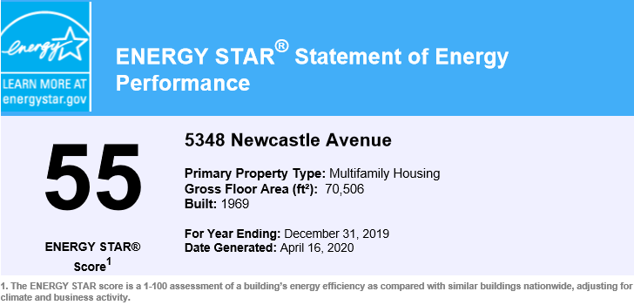

Currently the facility has a Site Energy Use Index (EUI) of Click or tap here to enter text. kBtu per square foot while the national median site EUI is Click or tap here to enter text. kBtu per square foot. The building Site Energy Use Index is #DIV/0! equal than the national median.
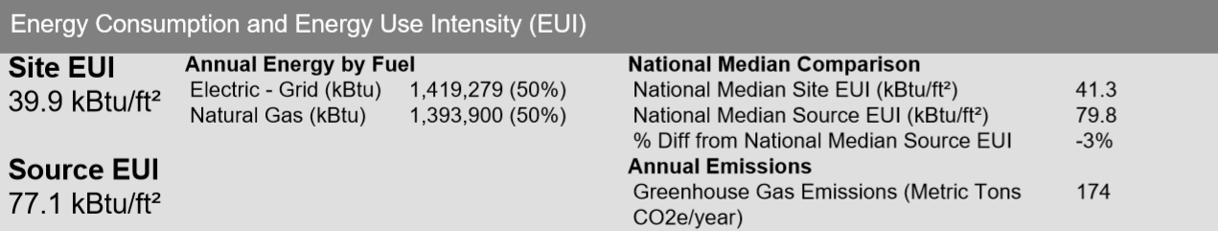

Energy Use Analysis
This section summarizes an energy analysis of purchased electricity and natural gas by end-use. Section J.5 below includes a tabular summary of electricity and natural gas usage and costs over a one (1) year period. Section J.4 offers a detailed analysis of the effects of weather on energy consumption.
Note: The utility analysis is based on LADWP whole building aggregate data (Tenant and common areas).
Each tenant electric and gas usage are metered and billed individually by LADWP and SoCalGas respectively.
The commons areas gas and electric usage are metered separately and paid by the building Owner(s )/ Management.

The following observations, table and graphs summarize the results of the annual electricity and natural gas usage and cost analysis.

Aggregated Electricity
VEG reviewed gas and electric utility bills from January 2021 through December 2021. During this period, the building consumed 0 kWh, or $0 worth of electricity. The chart below shows monthly electricity usage and costs.

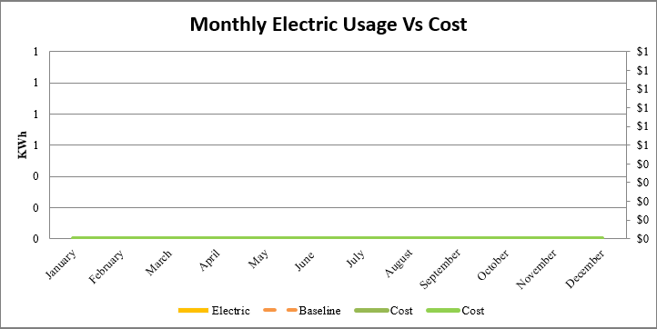

Aggregated Natural Gas
This building purchases natural gas from SoCal Gas at an estimated rate of #DIV/0!/therm. The building consumed 0 therms, or $0 worth of natural gas during the 12 months analyzed. The chart below shows the monthly natural gas usage and costs.

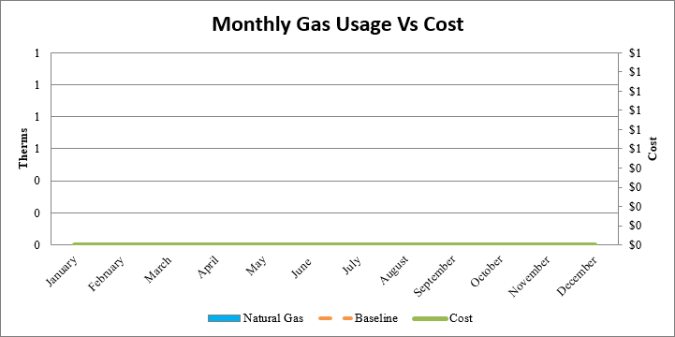

Building Energy End Use Charts

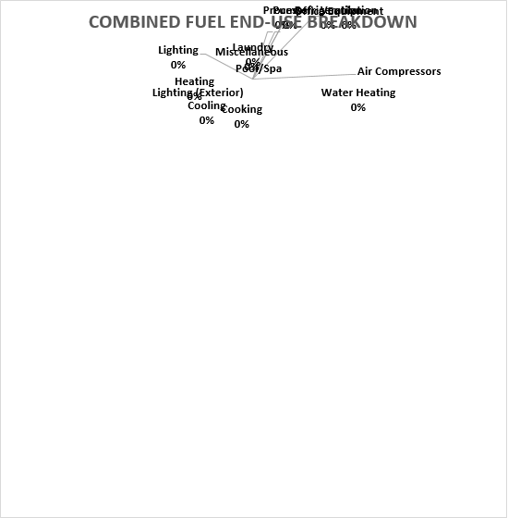

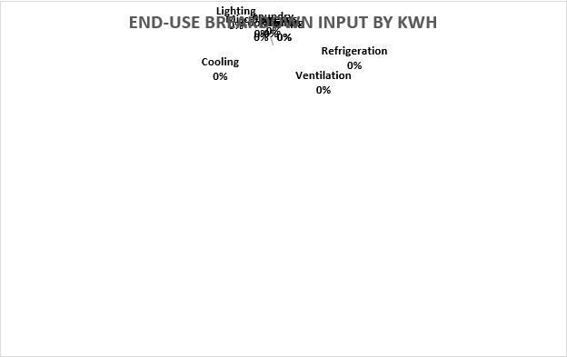
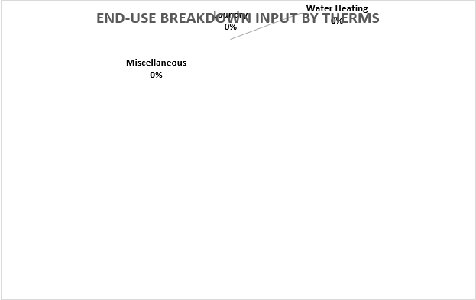

Weather Effects on Energy Use
A cooling degree day (CDD) is a measurement designed to quantify the demand for energy needed to cool buildings. It is the number of degrees that a day's average temperature is above 65º Fahrenheit (18º Celsius). A similar measurement, heating degree day (HDD), reflects the amount of energy needed to heat a home or business.

Gas Usage and Heating Degree Days – [Delete if Not Applicable]
The heating degree days (HDD) are used in comparison to actual gas consumption. This analysis does not apply to this building since space heating is provided by electric resistance.

Electric Usage and Heating Degree Days – [Delete if Not Applicable]
The heating degree days (HDD) are used in comparison to actual electric consumption. This analysis show that the electric consumption during the heating season follows the HDD trend.
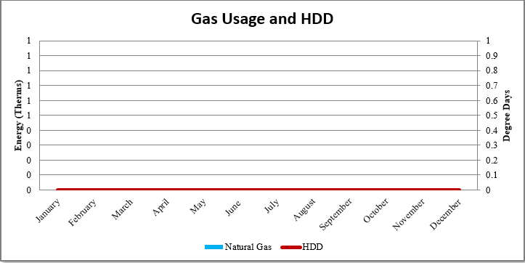

Electric Usage and Cooling Degree Days
The cooling degree days (CDD) are used for comparison to actual electric usage. As expected, an analysis of the kWh usage shows that the building electric consumption follows the CDD trend.

In general, electric usage is affected by increases in CDDs. Typically, energy usage closely follows seasonal variations and changes from this pattern are likely due to buildings control systems and occupant behavior.

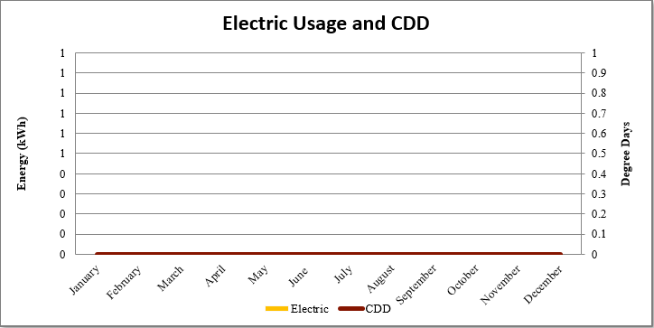

Aggregated Electric and Gas Consumption Table

 |  | WEATHER DATA (65°F) |  | ELECTRICITY USE DATA |  |  |  | GAS USE DATA
Month | Year | HDD | CDD | kWh Usage | Total Cost | Avg. Cost / kWh | Electric MMBtu | Therms | Total Gas Charges | Cost / Therms | Gas MMBTU
January | 2021 | 0 | 0 | 0 | Total Bill ($) | #DIV/0! | 0 | 0 | $0 | #DIV/0! | 0
February | 2021 | 0 | 0 | 0 | $0 | #DIV/0! | 0 | 0 | $0 | #DIV/0! | 0
March | 2021 | 0 | 0 | 0 | $0 | #DIV/0! | 0 | 0 | $0 | #DIV/0! | 0
April | 2021 | 0 | 0 | 0 | $0 | #DIV/0! | 0 | 0 | $0 | #DIV/0! | 0
May | 2021 | 0 | 0 | 0 | $0 | #DIV/0! | 0 | 0 | $0 | #DIV/0! | 0
June | 2021 | 0 | 0 | 0 | $0 | #DIV/0! | 0 | 0 | $0 | #DIV/0! | 0
July | 2021 | 0 | 0 | 0 | $0 | #DIV/0! | 0 | 0 | $0 | #DIV/0! | 0
August | 2021 | 0 | 0 | 0 | $0 | #DIV/0! | 0 | 0 | $0 | #DIV/0! | 0
September | 2021 | 0 | 0 | 0 | $0 | #DIV/0! | 0 | 0 | $0 | #DIV/0! | 0
October | 2021 | 0 | 0 | 0 | $0 | #DIV/0! | 0 | 0 | $0 | #DIV/0! | 0
November | 2021 | 0 | 0 | 0 | $0 | #DIV/0! | 0 | 0 | $0 | #DIV/0! | 0
December | 2021 | 0 | 0 | 0 | $0 | #DIV/0! | 0 | 0 | $0 | #DIV/0! | 0
TOTAL: |  | 0 | 0 | 0 | $0 | #DIV/0! | 0 | 0 | $0 | #DIV/0! | 0
Energy Summary Table
Effective Electrical $/kWh |  |  | #DIV/0!
Effective Electrical $/MMBtu |  |  | #DIV/0!
Effective Gas $/Therms |  |  | #DIV/0!
Effective Gas $/MMBtu |  |  | #DIV/0!
Gross Conditioned Area |  |  | 0
EUI (kBtu/ft^2) |  |  | #DIV/0!
ECI ($/ft^2) |  |  | #DIV/0!

Water Audit Report

Introduction
This report presents the results of the water audit conducted at Click or tap here to enter text..
A water audit (also known as an assessment) is a systematic survey of all water-using fixtures, appliances, equipment, and practices at a facility.
A water audit can:
- Identify leaks, areas of excessive consumption, and other opportunities for efficiency improvements.
- Identify the degradation of previously efficient devices.
- From the basis of efficiency improvement and investment planning (identifies best returns on investment) Provide a benchmark for measuring water efficiency program successes.
The multi-step water audit process was performed at Click or tap here to enter text. on Click or tap here to enter text. & Click or tap here to enter text., the water audit process includes collecting the data necessary to estimate water use at the equipment level, surveying the equipment to understand water consumption, investigating water-conservation opportunities, and conducting an economic analysis to determine the project’s effectiveness.

Water Audit Procedures
The water audit procedure consists of the following tasks:
Note: Each task is an independent procedure and those that do not apply to the building are omitted.
Documents Review (when available)
- Metering/utility bills analysis
- Review Plumbing plans
- Review Irrigation site map
- Review a comprehensive maintenance report of fixtures kept by on-site staff to determine any potential maintenance needs
Plumbing Fixtures Inventory & Assessment:
- Visually Inspect plumbing fixtures for leaks or other maintenance needs.
- Measure plumbing fixtures using water flow rate bag
- Measure plumbing fixtures water waste from leaks using drip gauge
- Measure water pressure using water pressure gauge
Appliances Inventory:
- Collect name plate for water using appliances such as dishwashers and clothes washers
- Identify the water factors for the above
Irrigation System Assessment:
- Measure irrigated area via google satellite imagery or by using surveyors’ wheel
- Identify irrigation system controllers/ timers and determine the number of stations served by each controller
- Figure out how often each station is activated and for how long.
- Determine if there are rain or moisture sensors that determine system activation
- Turn on each watering station in the irrigation system and Inspect
- water delivery devices (sprinkler heads, bubblers, drip emitters, etc.),
- Check for water runoff/overspray and over watered areas
- Note paved areas wet but the irrigation devices,
- Identify the type of plants used
Cooling Tower Assessment:
- Collect the Cooling tower name plate data (tonnage)
- Check float valves for proper operation.
- Check if water is overflowing into the sump
- Verify the CT Cycles of concentration
- Evaluate cooling towers for water leaks and excess water consumption.
- Verify that cooling tower is equipped with a conductivity meter
- Collect water supply & return setpoints
Water Features:
- Check water feature (pools, fountains and ponds) for leaks
- Review water feature schedules
- Check if a recirculating water pump working properly

WEMs Cost Savings Summary Table
The following table summarizes the overall performance of water efficiency measures recommended as part of the Water Audit Report.

WATER EFFICIENCY MEASURES (WEM)
WEM # | Descriptions | Cost Savings | KWH Savings | KW Savings | Therms Savings | Lbs Steam Savings | Gallons Savings | Estimated Project Cost | Incentives | Net Cost | Useful Life (Years)
WEM 1 |  | #DIV/0! |  |  |  |  |  |  |  | $0
WEM 2 |  | #DIV/0! |  |  |  |  |  |  |  | $0
WEM 3 |  | #DIV/0! |  |  |  |  |  |  |  | $0
WEM 4 |  | #DIV/0! |  |  |  |  |  |  |  | $0
WEM 5 |  | #DIV/0! |  |  |  |  |  |  |  | $0
WEM 6 |  | #DIV/0! |  |  |  |  |  |  |  | $0
WEM 7 |  | #DIV/0! |  |  |  |  |  |  |  | $0
WEM 8 |  | #DIV/0! |  |  |  |  |  |  |  | $0
WEM 9 |  | #DIV/0! |  |  |  |  |  |  |  | $0
WEM 10 |  | #DIV/0! |  |  |  |  |  |  |  | $0
TOTAL |  | #DIV/0! | 0 | 0 | 0 | 0 | 0 | $0 | $0 | $0

*Energy and cost savings resulting from WEM __ will be realized by tenants, but the landlord will benefit from reduced maintenance cost (parts and labor).

Existing Conditions and Observations

Domestic Indoor Water Use

Non-Domestic Indoor Water Use (CT, HVAC)

Outdoor Water Use (Irrigation & Landscaping)

Industrial Process Water use

Water Efficiency Measures Recommended
As a part of the water audit report, includes a series of measures (WEMs), which when implemented should accrue water cost reductions approaching those estimated for each measure. The development of these measures is still conceptual and will require additional technical due diligence, planning and design prior to implementation.

WEM 1: xxxxxxxxxxx
Existing Condition: xxxxxxxxxx

Recommendation: xxxxxxxxxx

Supporting Images:
xxxxxxxxxx | xxxxxxxxxxx

WEM 2: xxxxxxxxxxx
Existing Condition: xxxxxxxxxx

Recommendation: xxxxxxxxxx

Supporting Images:
xxxxxxxxxx | xxxxxxxxxxx

WEM 3: xxxxxxxxxxx
Existing Condition: xxxxxxxxxx

Recommendation: xxxxxxxxxx

Supporting Images:
xxxxxxxxxx | xxxxxxxxxxx

WEM 4: xxxxxxxxxxx
Existing Condition: xxxxxxxxxx

Recommendation: xxxxxxxxxx

Supporting Images:
xxxxxxxxxx | xxxxxxxxxxx

WEM 5: xxxxxxxxxxx
Existing Condition: xxxxxxxxxx

Recommendation: xxxxxxxxxx

Supporting Images:
xxxxxxxxxx | xxxxxxxxxxx

WEM 6: xxxxxxxxxxx
Existing Condition: xxxxxxxxxx

Recommendation: xxxxxxxxxx

Supporting Images:
xxxxxxxxxx | xxxxxxxxxxx

WEMs Already Implemented
The management has taken proactive steps in increasing the water efficiency of the property. The following upgraded equipment was observed to be installed during the site visit.
- xxxxxxxxxx
- xxxxxxxxxx
- xxxxxxxxxx
- xxxxxxxxxx
- xxxxxxxxxx
- xxxxxxxxxx
Supporting Images:
xxxxxxxxxx | xxxxxxxxxxx
xxxxxxxxxx | xxxxxxxxxxx
xxxxxxxxxx | xxxxxxxxxxx

WEMs to Consider
The following measures have been identified to increase the water efficiency of the property; however, these measures were priced using standard cost estimates, which were unable to justify the Return on Investment (ROI). Nonetheless, the viability of these measures should be investigated further by the client.

xxxxxxxxxxxx
Existing Condition: xxxxxxxxxx

Recommendation: xxxxxxxxxx

Supporting Images:
xxxxxxxxxx | xxxxxxxxxxx

xxxxxxxxxxxx
Existing Condition: xxxxxxxxxx

Recommendation: xxxxxxxxxx

Supporting Images:
xxxxxxxxxx | xxxxxxxxxxx

WEMs Requiring Further Investigation
The following section outlines additional water efficiency measures which require greater study and testing to determine the on-site feasibility. The required tests exceed the scope of this study; however, these measures are encouraged to be investigated further.

XXXXXXXXXXX
Existing Condition: xxxxxxxxxx

Recommendation: xxxxxxxxxx

Supporting Images:
xxxxxxxxxx | xxxxxxxxxxx

Non-Efficiency Water Measure/s
The following water measure/s do not directly conserve water usage but can result in decreased water and/or sewage utility costs.

XXXXXXXXXXX
Existing Condition: xxxxxxxxxx

Recommendation: xxxxxxxxxx

Supporting Images:
xxxxxxxxxx | xxxxxxxxxxx

Water Use Analysis

Building Water Use Intensity (WUI)
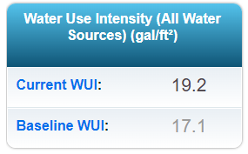

ENERGY STAR® Water Scorecard (for MF only)
The U.S. Environmental Protection Agency's (EPA) Water Score is generated by the ENERGY STAR® Portfolio Manager® tool and supported by WaterSense®. The Score offers a 1 - 100 measurement of how efficiently this property uses water, compared to similar properties nationwide, when normalized for climate and operational characteristics.
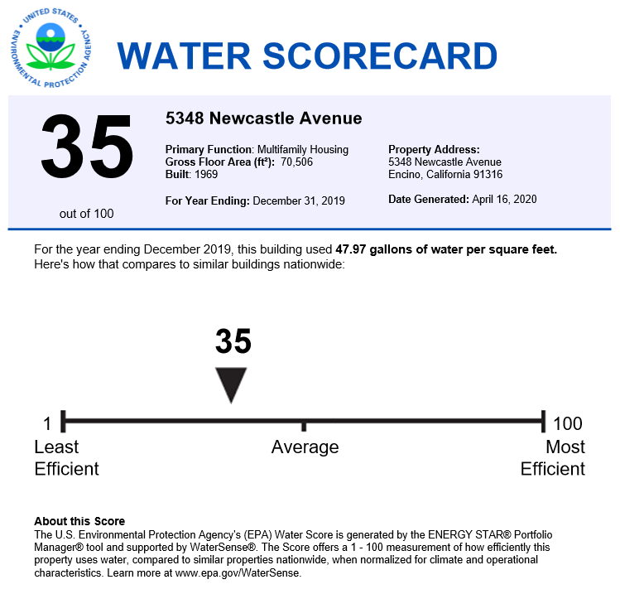

Water Usage and Cost
This section summarizes water analysis of purchased water by end use (water Balance). It includes a tabular summary of water usage and costs over a one (1) year period in addition to the ENERGY STAR® Water Scorecard.
Note: The water analysis is based on LADWP whole building aggregate data (Tenant and common areas).
Tenant water use is not separately metered, the building Owner(s) / Management are responsible for the building water cost.
Note: The water analysis is based on LADWP whole building aggregate data.
Tenant(s) is/are responsible for the building water use and cost.

The following observations, table and graphs summarize the results of the annual water usage and cost analysis.
VEG reviewed water utility bills from January 2021 through December 2021. The building purchases water from LADWP, during this period, the building consumed - gallon, or $0 worth of water and sewer at an average rate of #DIV/0!/gallon under Schedule B-Multi-Dwelling Unit.

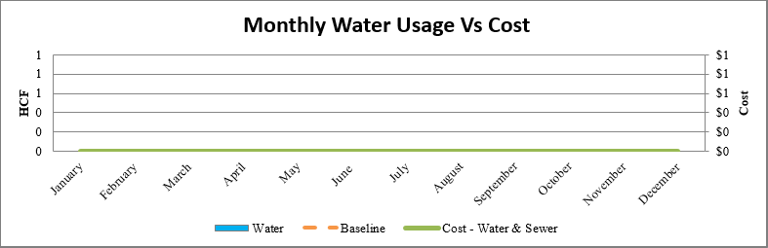

Water Balance Chart
The distribution of water uses shown below is based on the auditor’s field observations, as well as industry standard estimates.
Several factors affect indoor water use:
- Type, age, and condition of water-using fixtures
- Climate
- The price of water the tenants pay
Outdoor water use is highly site-specific and depends on the square footage of landscaped areas and the efficiency of irrigation systems and procedures. Fountains, and other decorative water fixtures will also impact the volume of water used outdoors.

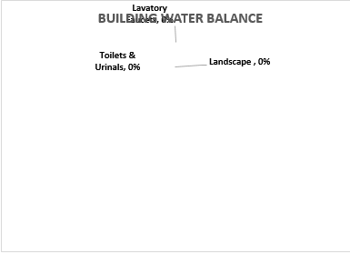

Water Consumption Table

Water Service
Month | Year | Water HCF/CCF | Water ($)
January | 2021 | 0 | 0
February | 2021 | 0 | 0
March | 2021 | 0 | 0
April | 2021 | 0 | 0
May | 2021 | 0 | 0
June | 2021 | 0 | 0
July | 2021 | 0 | 0
August | 2021 | 0 | 0
September | 2021 | 0 | 0
October | 2021 | 0 | 0
November | 2021 | 0 | 0
December | 2021 | 0 | 0
Total |  | 0 | $0

Retro-commissioning Report

Introduction
This report presents the results of the retro-commissioning study performed at Click or tap here to enter text. on Click or tap here to enter text. & Click or tap here to enter text.. This retro-commissioning study was completed as part of a the EBEWE program established by Los Angeles Municipal Code

Objectives
The primary objectives for conducting these activities are:
- Enhance documentation of the operational and maintenance (O&M) requirements for the equipment and systems included.
- Analyze operating conditions through trending of performance measurements.
- Optimize control systems through calibration of critical sensors, review metered data and trend logs, and functional equipment testing.
- Identify operational and maintenance enhancements that result in improvements in energy efficiency, occupant comfort, or indoor air quality.
- Identify O&M staff training needs.

Overview of Results
The RCx study identified the following cost-effective Retro-commissioning conservation measures (RCMs) ranging from low-cost/no-cost improvements to capital grade investments that should be undertaken at the end of the equipment’s useful life.
- Click or tap here to enter text.
- Click or tap here to enter text.
- Click or tap here to enter text.
- Click or tap here to enter text.
- Click or tap here to enter text.
- Click or tap here to enter text.
- Click or tap here to enter text.
- Click or tap here to enter text.
- Click or tap here to enter text.
- Click or tap here to enter text.

RCMs Cost Savings Summary Table
The following table summarizes the overall performance of retro-commissioning measures recommended as part of the Retro-commissioning Report.

RCMs
EEM # | Descriptions | Cost Savings | KWH Savings | KW Savings | Therms Savings | Lbs Steam Savings | Gallons Savings | Estimated Project Cost | Incentives | Net Cost | Useful Life (Years)
RCM 1 |  | #DIV/0! |  |  |  |  |  |  |  | $0
RCM 2 |  | #DIV/0! |  |  |  |  |  |  |  | $0
RCM 3 |  | #DIV/0! |  |  |  |  |  |  |  | $0
RCM 4 |  | #DIV/0! |  |  |  |  |  |  |  | $0
RCM 5 |  | #DIV/0! |  |  |  |  |  |  |  | $0
RCM 6 |  | #DIV/0! |  |  |  |  |  |  |  | $0
RCM 7 |  | #DIV/0! |  |  |  |  |  |  |  | $0
RCM 8 |  | #DIV/0! |  |  |  |  |  |  |  | $0
RCM 9 |  | #DIV/0! |  |  |  |  |  |  |  | $0
RCM 10 |  | #DIV/0! |  |  |  |  |  |  |  | $0
TOTAL |  | #DIV/0! | 0 |  | 0 | 0 |  | $0 | $0 | $0

Overview of Project Steps
In general, the following items summarize the project steps. Some of the steps may not apply to your project.
- Review existing systems and related documentation
- Develop Retro-Commissioning Plan
- Implement diagnostic monitoring / trending
- Perform functional tests
- Analyze the monitoring / trending and test data
- Assess and document the current operating strategies and sequences of operation for all systems and equipment included
- Document O&M improvement opportunities
- Calculate energy impacts and develop implementation cost estimates for O&M opportunities
- Develop and deliver the Final Retro-Commissioning Report

Retro-commissioning Plan
According to EBEWE guideline SEC. 91.9704., only “Base Building Systems” (BBS) are subject to the retro-commissioning study. The BBS are the systems and subsystems of a building that use or distribute energy and/or water and/or impact the energy and/or water consumption.
Base building systems shall not include:
  - Systems or subsystems owned by a tenant or for which a tenant bears full maintenance responsibility, that are within the tenant’s leased space and exclusively serve such leased space, and for which the tenant pays all the energy and water bills according to usage and demand as measured by a meter or sub-meter.
  - Systems or subsystems owned by a residential unit owner that exclusively serve the residential unit of that owner.
  - Systems or subsystems that operate industrial applications such as manufacturing.

Where is not possible to include all major building systems and equipment as defined above, the largest energy using equipment as well as systems known for having problematic controls, or operational and comfort problems are selected.

For this building the following equipment are included in the study:

Cooling systems

Central cooling plant

Primary air-handling units (AHUs)

Terminal units

DX systems

Heating systems

Central boiler plant

Primary heating systems

Lighting systems & Control

EMS/BMS System and Controls

Domestic hot water equipment

Irrigation system

Functional Performance Test Methodology
Vert conducted a site assessment to learn how the existing systems and equipment are operated and maintained.
During the site visit the RCx agent conducted an in-depth site survey of equipment conditions, interviewed building staff regarding operating strategies and discussed significant issues related to equipment and operations. Based on the site assessment the agent utilized one or more of the Functional Performance Test methods listed below to assess the performance of a representative sample of different building systems.

Stand-Alone Portable Data Loggers
Data loggers provide valuable information on building-system behavior that may not be available from the building-automation system (BAS) or where a BAS does not exist. They can also be used to confirm operation of the BAS itself as sensors or actuators may not be accurate or functional. See Appendix xx for list of systems where data loggers were deployed.

BAS Trend Data
Vert provides a detailed request for required trend logs from the building Engineer / Management or from the Controls Vendor, who executes the trends and provides the data to Vert in .CSV format. See Appendix xx for Trend Log request.

System & Equipment Tests Agent conducts tests on selected systems and equipment with the assistance of facility staff and Controls Vendor as required. The tests comprised changing parameters, set points or conditions, and observing and documenting the actual system or equipment response through various modes and conditions (both simulated and real).Refer to appendix XX for the test sheets.

Spot Measurements
Spot measurements of temperature, air quality, pressure, flow, or other parameters may be sufficient for some types of equipment or systems. Typically, spot measurements are used for systems where trend logging is not available and where portable data logger application is impractical. Refer to appendix XX for the test sheets.

Observation
During the site survey the Agent performs a System Condition Analyses on facility equipment to assess its current operational and maintenance conditions. The goal of this activities is the identification of O&M issues or physical conditions affecting the performance of equipment and systems, based on direct observation. Typical items to be checked include:
- Cleanliness of coils, louvers, and other surfaces
- Serviceability of filters, belts, valves, dampers, ducts, flex connections, insulation, door seals and glazing
- Completion of required preventative maintenance actions
- Overall equipment physical condition
Collected data is analyzed. Mechanical and Electrical equipment, systems and control sequences are compared to the original design intent. Issues and potential improvements are identified and documented. Energy calculations are performed for capital cost measures that appear to have the most impact on comfort, energy, or indoor air quality. Implementation costs for the measures are estimated, and results are presented in the following sections of this report.

Assessment Team
The Assessment Team is led by Dr William D. Shoard, P.E., and supported by the efforts of the engineering/auditor staff which includes Sam Rios, Ryan Hillis, Maya Witenberg, Bill Leslie, Leon Liu, Paul Martinez, and Jared Norton.
This study was facilitated by the efforts of Project Manager Jill Jones from Vert Energy Group, as well as Click or tap here to enter text. Supervisor Click or tap here to enter text.
Project Team
Role | Name | Company
Chief Engineer | Dr William D. Shoard, P.E. | Vert Energy Group
Project Manager | Jill Jones | Vert Energy Group
Energy Efficiency Engineer | Sam Rios | Vert Energy Group
Energy Efficiency Engineer | Ryan Hillis | Vert Energy Group
Junior Energy Analyst | Maya Witenberg | Vert Energy Group
Auditor/RCx Agent | Bill Leslie | Vert Energy Group
Energy Efficiency Engineer | Leon Liu | Vert Energy Group
Auditor/RCx Agent | Paul Martinez | Vert Energy Group
Auditor/RCx Agent | Jared Norton | Vert Energy Group
Management | 0 | 0
Management | 0 | 0
Management | 0 | 0

Date of site visit # 1: Click or tap here to enter text.
Date of site visit # 2: Click or tap here to enter text.

Functional Performance Test Findings & Recommendations

RCM1: XXXXXXXX
Existing Condition: xxxxxxxxxx

Recommendation: xxxxxxxxxx

Supporting Images:
xxxxxxxxxx | xxxxxxxxxxx

RCM 2: XXXXXXXX
Existing Condition: xxxxxxxxxx

Recommendation: xxxxxxxxxx

Supporting Images:
xxxxxxxxxx | xxxxxxxxxxx

RCM 3: XXXXXXXX
Existing Condition: xxxxxxxxxx

Recommendation: xxxxxxxxxx

Supporting Images:
xxxxxxxxxx | xxxxxxxxxxx

RCM 4: XXXXXXXX
Existing Condition: xxxxxxxxxx

Recommendation: xxxxxxxxxx

Supporting Images:
xxxxxxxxxx | xxxxxxxxxxx

Operational Training
Operational training of Section 91.9706.1.3 of the LAMC was not necessary for this building due to one or more of the following reasons:
- The building engineer is already well trained in these matters.
- The building does not have a dedicated building engineer responsible for day-to-day operations.
- Repairs and maintenance are conducted by third party vendors.
- There were no significant findings that require a formal training.
However, Vert’s engineer has discussed with the person in charge of the building about the operation and maintenance issues observed, and how to correct them. Many of these remarks involved general maintenance, scheduling, and control strategies.
These observations are included in the retro-commissioning report (RCMs) and were discussed during the report presentation.
===========
Operational training of Section 91.9706.1.3 of the LAMC was conducted and include the following: suggested documents and updates to the building system operation manual.
- This Energy Audit, Water Audit and Retro-comissioning study, which include:
  - Narrative of all systems investigated, a brief description of the system, its purpose and general operation, and operational factors that impact energy and water usage.
  - A description of and rationale for all recommended measures, including proposed changes to automatic and manual control strategies, noting special operating and maintenance limitations.
  - Occupancy schedules, temperature, humidity, and ventilation requirements for different spaces, and identification of the mechanical systems which serve them.
- List of points of the facility Supervisors, Managers as well as List of Vendors. Refer to appendix XX
- Recommendations for equipment maintenance frequency Refer to appendix XX

Appendices

Assumptions
The assumptions utilized in this energy audit include but are not limited to following:
A. Cost Estimates noted within this report are based on industry accepted costing data such as RS MeansTM Cost Data, contractor pricing and engineering estimates. All cost estimates for this level of auditing are +/- 20%. The cost estimates indicated within this audit should be utilized by the owner for prioritizing further project development post the energy audit. Project development would include investment grade auditing and detailed engineering.
B. Energy savings noted within this audit are calculated utilizing industry standard procedures and accepted engineering assumptions. For this level of auditing, energy savings are not guaranteed.
C. Information gathering for each facility is strongly based on interviews with operations personnel. Information dependent on verbal feedback is used for calculation assumptions including but not limited to the following:
- operating hours
- equipment type
- control strategies
- scheduling
D. Information contained within the major equipment list is based on the existing owner documentation where available (drawings, O&M manuals, etc.). If existing owner documentation is not available, catalog information is utilized to populate the required information.
E. Equipment incentives and energy credits are based on current pricing and status of rebate programs. Rebate availability is dependent on the individual program funding and applicability.
F. Equipment (HVAC, Plumbing, Electrical, & Lighting) noted within the energy and water saving measures recommendation is strictly noted as a basis for calculation of energy savings. The owner should use this equipment information as a benchmark when pursuing further investment grade project development and detailed engineering for specific energy conservation measures.
G. Utility bill annual averages are utilized for calculation of all energy costs unless otherwise noted. Accuracy of the utility energy usage and costs are based on the information provided. Utility information including usage and costs is estimated where incomplete data is provided.
- Blended kWh Rate: #DIV/0!
- Blended Therm rate: #DIV/0!
- Blended Lbs Steam rate: $0.03
- Water & Sewer Cost per gallon: $0.10

Equations:
- kWh_{saved} = kWh_{baseline} - kWh_{post retrofit}
- $Lighting Upgrade kWh Saving=\left(\# Fixtures\right)(\#Lamps/ Fixture) (\frac{1 KW}{1000 W})(Wpre-Wpost)(Hrs operating)$
- $Lighting Control Upgrade kWh Saving=\left(\# Fixtures\right)(\#Lamps/ Fixture) (\frac{1 KW}{1000 W})(Wpre* Hrs pre)-(Wpost*Hrs post)$
- Average Demand (kW_{avg}) = (Cooling Capacity (kBtu/h)) / (SEER)
- Annual Energy Use (kWh/yr) = (kW_{avg})*(equivalent full load annual hours)
- Motor Draw (kWh) = (hp)(0.746 kW/hp)(%Loaded)(hours)/Efficiency
- Conduction (Btu/h) = (U-Value)(Area in sq ft)(T_{outside}-T_{inside})
- Ventilation / Infiltration (Btu/h) = (1.085)(CFM) (T_{outside}-T_{inside})
- Efficiency Conversions
  - kW/ton = 12 / EER
  - COP = EER / 3.412
  - COP = 3.516 / (kW/ton)
- Heat Transfer in Water
  - Capacity (kBTUh) = GPM * ΔT / 2
- Power from hp
  - Power (kW) = 0.746 * Power (hp)
- Pump power
  - Waterpower (hp) = (ft of head) * (GPM) / 3960
  - Pump Power = Waterpower / [Pump eff * Motor eff]
- $Building Site EUI=\frac{(Electric Usage in kBTU+Gas Usage in kBTU)}{Building Square Footage}$

Supporting Documents

Equipment List

HVAC (Copy and paste “Keep Source Formatting (K)”)
HVAC
Equipment Description | # of Units | Equipment Location | Age | Manufacturer & Model | Capacity

Lighting (Copy and paste “Keep Source Formatting (K)”)
Existing Lighting
Floor | Location | # Fixtures | # Lamps/Fixt | Tot # Lamps | Lamp Type | Lamp Watts

Plumbing (Copy and paste “Keep Source Formatting (K)”)
Existing Water Fixtures
Fixtures | Average Flow | Quantity

Domestic Hot Water (DHW)(Copy and paste “Keep Source Formatting (K)”)
Domestic Hot Water System
Equipment Description | # of Units | Equipment Location | Age | Manufacturer & Model | Input | Efficiency

Other (Copy and paste “Keep Source Formatting (K)”)

Functional Test Sheets
(Copy and paste “Keep Source Formatting (K)”)

Building drawings
(Copy and paste as a Picture)

Equipment Literature
(Copy and paste as a Picture)

Other

Equivalent Full Load Hours (EFLH)
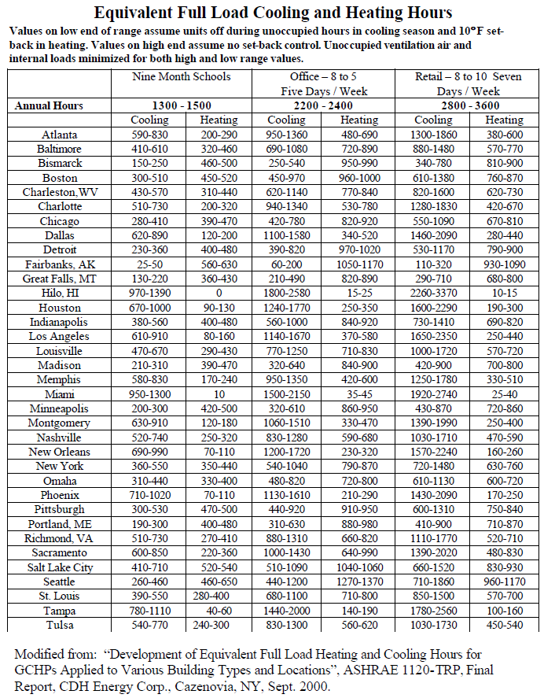

Additional O& M
Suggested Basic Inspections & Record Keeping
The basic inspections below are to make sure that the equipment and surrounding areas are clean, no unusual noises or visual damages detected that require immediate attention and that records are kept. The items listed do not required any technical skills and do not represent a maintenance program. The items address only the portion of the basic inspections related to the common area lightings, irrigation system, boiler, and HVAC units. It is not a comprehensive list of inspections, and it does not include the building safety equipment, building envelope, all building mechanical, electrical and plumbing equipment and should not duplicate or replace the operation and maintenance O&M of the building systems.
- Record keeping:
  - Equipment information: Keep all manufacturer's instructions and manuals available in an accessible location.
  - Maintain A log for all Equipment including all recommended preventive maintenance and servicing dates. A copy of the work order, which confirms the performance of scheduled maintenance, or the repair, or replacement of any parts, should be placed in file to establish a record of all work performed on the equipment or systems.
- Create and follow a schedule of O&M items to make sure operations checks and maintenance procedures are performed with the recommended frequency (O&M conducted by contactors).
- Implement a routine walkthrough to visually inspect the following for cleanliness and unusual noises (where applicable).
  - Office/lobby HVAC equipment
- Implement a routine walkthrough to visually inspect the Irrigation system for the following
  - Burst sprinkle heads
  - Water runoffs
- Implement a routine walkthrough to visually inspect lighting equipment in garage, hallways, exterior and other common areas for:
  - Burned bulbs or nonfunctional fixtures
  - Exterior lights ON during daytime hours
  - Fixtures cleanness
- Implement a routine walkthrough to visually inspect the following for cleanliness and unusual noises (where applicable)
  - Office/lobby HVAC equipment
- Implement a quarterly HVAC inspection (to be conducted by your maintenance personnel):
  - Filters are in place
  - Correct filter size is used
  - Filters are clean
  - Thermostat’s battery operational
  - HVAC unit’s cleanliness
  - HAVC units suction line damage
  - HVAC units’ unusual noises
- Implement a Boiler routine inspection (to be conducted by your maintenance personnel):
  - Boiler and surrounding area are clean
  - No water leaks
  - Insulation in place and not damaged
- Implement routine inspection for Supply and exhaust fans (to be conducted by your maintenance personnel):
  - Unusual noises
  - Excess variation
  - Cleanliness

LADWP Rebates
LADWP AC Optimization Program
https://ladwpactuneup.com/

Custom Performance Program:
https://www.ladwp.com/ladwp/faces/ladwp/commercial/c-savemoney/c-sm-rebatesandprograms/c-sm-rp-cpp?_afrLoop=670489594141570&_afrWindowMode=0&_afrWindowId=null#%40%3F_afrWindowId%3Dnull%26_afrLoop%3D670489594141570%26_afrWindowMode%3D0%26_adf.ctrl-state%3Dt9tbtd5eq_4

Water Conservation Measures
https://www.ladwp.com/ladwp/faces/wcnav_externalId/a-w-c-waterconsmeasures?_adf.ctrl-state=fx4bexulu_4&_afrLoop=1182326841354352&_afrWindowMode=0&_afrWindowId=920njbj4t_22#%40%3F_afrWindowId%3D920njbj4t_22%26_afrLoop%3D1182326841354352%26_afrWindowMode%3D0%26_adf.ctrl-state%3D920njbj4t_54



